**Quantitative assessment of the diagnostic role of CDH13 promoter methylation in NSCLC**

**LUSC**

Non-island Island

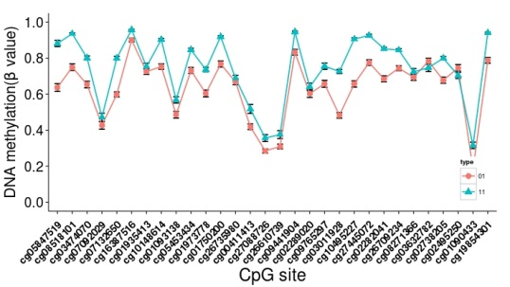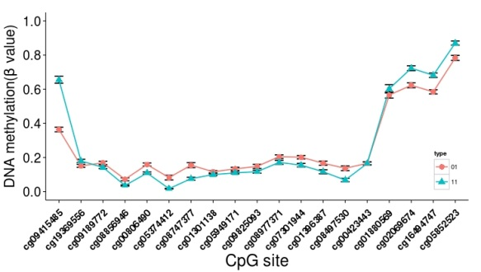

**Figure 1．Methylation profle of Non and CpG island region in LUSC**

**LUAD** Non-island Island

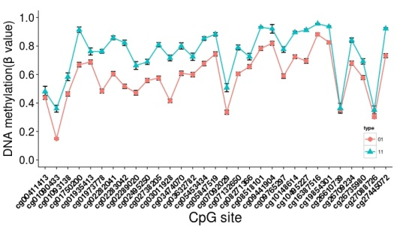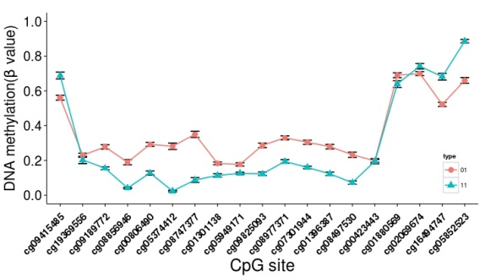

**Figure 2．Methylation profle of Non and CpG island region in LUSC**

Significant differences of DNA methylation in the CpG island were found between LUSC and LUAD. More important, Non-CpG island were significantly different with CpG island.